Types of Routes
# Source: Chatgpt (GPT‑5 Mini) at [12/14/2025]
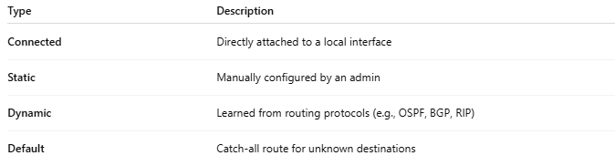
Type | Description
Connected | Directly attached to a local interface
Static | Manually configured by an admin
Dynamic | Learned from routing protocols (e.g., OSPF, BGP, RIP)
Default | Catch-all route for unknown destinations

